Measurement Sheet
Shotguns, Arizona Bells, Woolies
Name |  |  |  |  |  |  |  | Date
Phone | ( )
Address |  |  |  |  |  |  |  | State |  | Zip
Shotguns |  | Armitas |  | Chinks |  | Woolies
A) Waist: |  | Measure around waist where you would like the chap belt to be. This is usually just
 |  | UNDER your pants belt.
B) Length: |  | Measure on the FRONT of the leg, from the bottom of your belt loops to the TOP of your
 |  | foot. Make sure your leg is bent a little – almost like your riding in your saddle.
C) Upper thigh: |  | Measure snug (NOT TIGHT) around the thigh at the largest point. USUALLY JUST UNDER
 |  | THE CROTCH.
D) Mid thigh: |  | Measure HALFWAY between the upper thigh and the center of the knee.Measure snug
 |  | (NOT TIGHT).
E) Knee: |  | Measure around the middle of the knee and kneecap WHILE IT IS BENT.
F) Calf: |  | Measure around the LARGEST part of the calf WITH YOUR BOOTS ON.
G) Drop: |  | Measure the distance from where the waist measurement was taken (usually just
 |  | under the belt buckle) straight down level with the crotch. Usually 5 to 6 inches.
H) Waist to Knee: | ____ | Measure from just under your belt to the middle of the knee.
I) Ankle: | ____ | Measure around the ankle WITH YOUR BOOTS ON. Leave tape a little loose to allow for
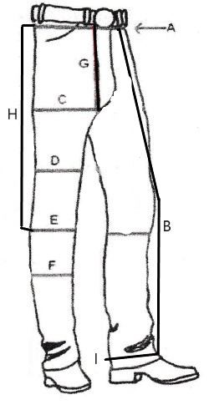

Single or Double Fringe: |  | Comments:
Color(s) of fringe: |  | Comments:
Fringe Length: |  | Comments:
Usually 6-8 inches
Belt buckle location: | Front |  | Back |  | Both
 | If you choose front, the back belt will be laced on unless otherwise specified.
Main color for body:
 | See pictures on our website for colors. If you do not see the color you want, let us
 | know and we can search for it.
Body shape: | Shotgun |  | AZ Bell
 | Comments:
 | _______________________________________ |  |  |  | ______
Yokes: | Stamping |  |  |  | Floral
 | Name |  |  |  | Brand
 | Because there are so many styles for yokes, you can message us a picture of what
 | you want.
Base Prices: |  | Included in Base Price:
Shotguns & AZ Bells | $500 | Single color. Laced-in zippers. Stamped yokes. One belt buckle.
Chinks | $400 | Single color. 3 conchos on each leg. Buckles on legs. Stamped yokes. One
 |  | belt buckle.
Armitas | $450 | Single color. 3 conchos on each leg. Buckles on legs. Stamped yokes.
Woolies | $700 | Single color. Laced-in zippers. Stamped yokes. One belt buckle.
Prices for Add-ons:
Single fringe |  | Included
Double fringe |  | $100
Front or back belt buckle |  | Included
Both front and back buckles |  | $35
Stamped yokes |  | Included
Floral yokes |  | $100
Brand/Name/Initials on yokes |  | $25 each
Message me about additional add-ons

See all we have to offer on our website:
www.RockingSSaddleShop.com
or Find us on Facebook: Rocking S Saddle Shop
Thank you for ordering with us!

